**1)Total Cost per Landing Page View**

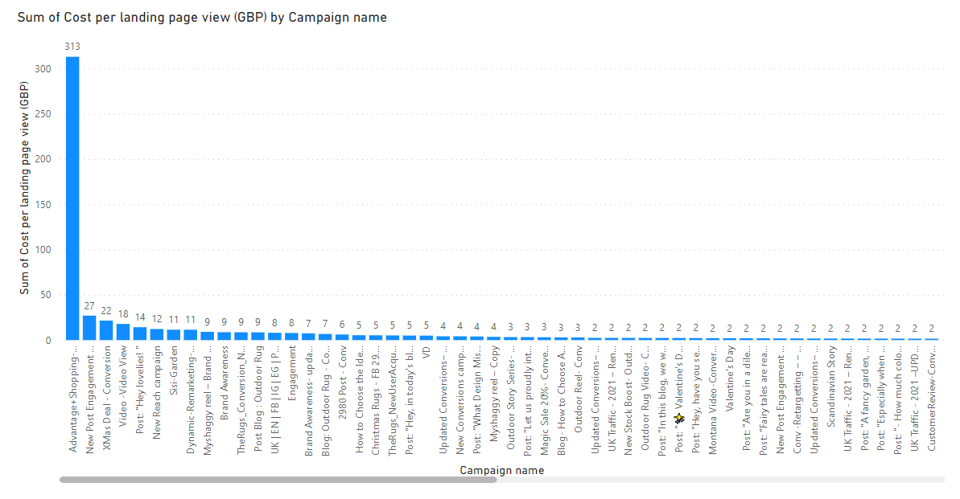

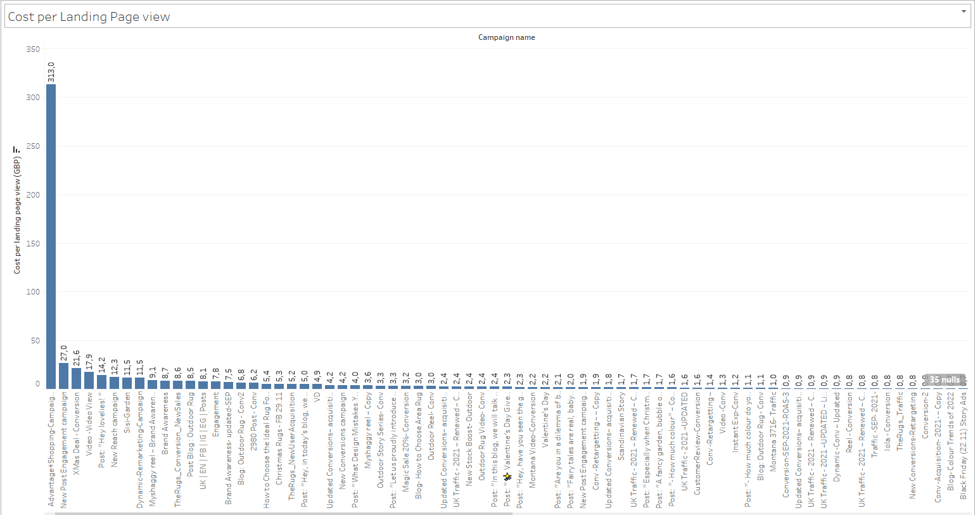

The chart above shows the total spend of landing page views. In this context, the Advantage Shopping campaign has been the landing page with the highest tracking cost in total.

**2)Click and Impression(A/B)**

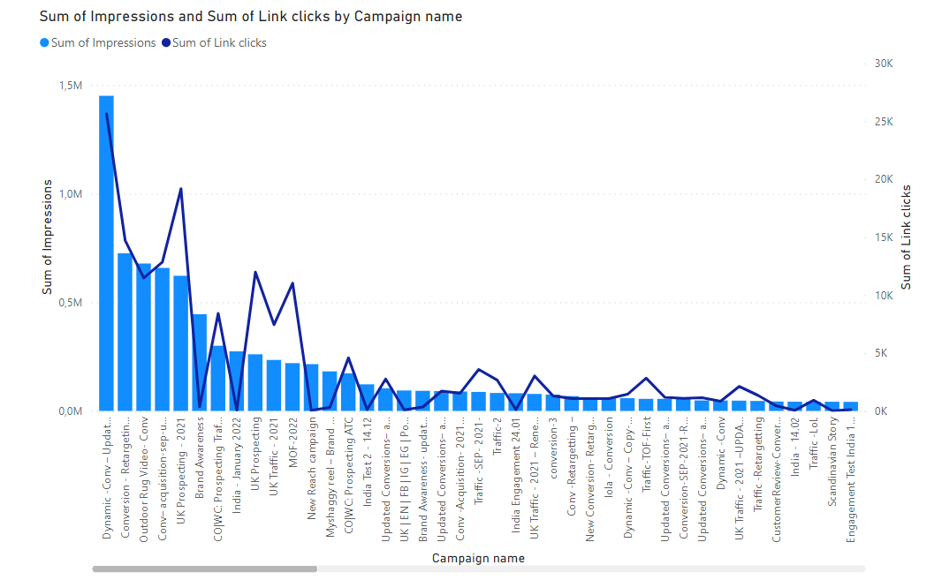

The graphic above is intended to show the relationship between ad interaction and clicks. The conclusion to be drawn from this graph is that there is a relatively positive relationship between interaction and clicking.

**3)Cost per Results**

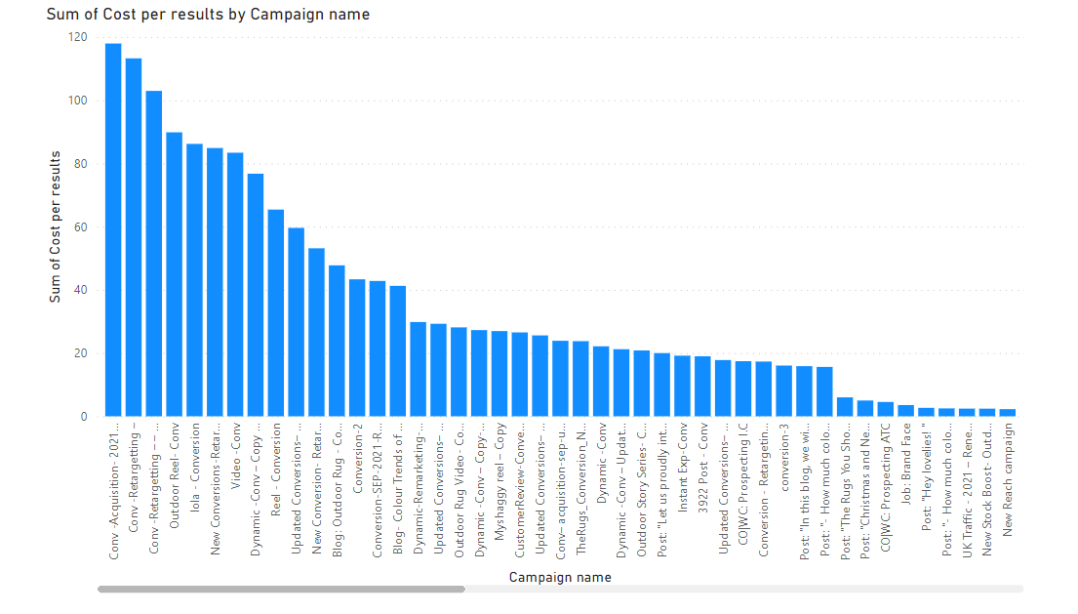

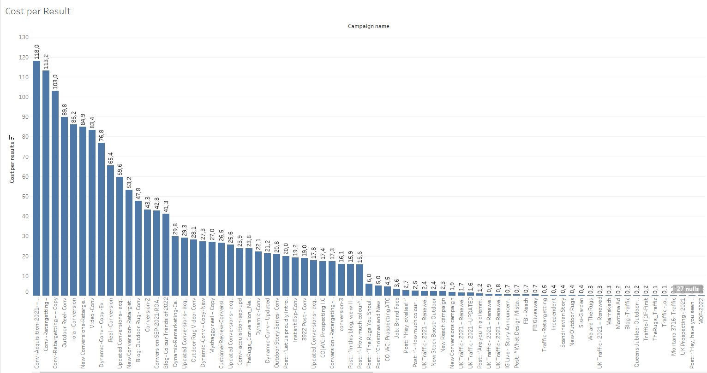

The above chart shows the CPR figures of the campaigns. It belongs mostly to the CTR Conv-Acquisition campaign.

**4)Reach and Impression(A/B)**

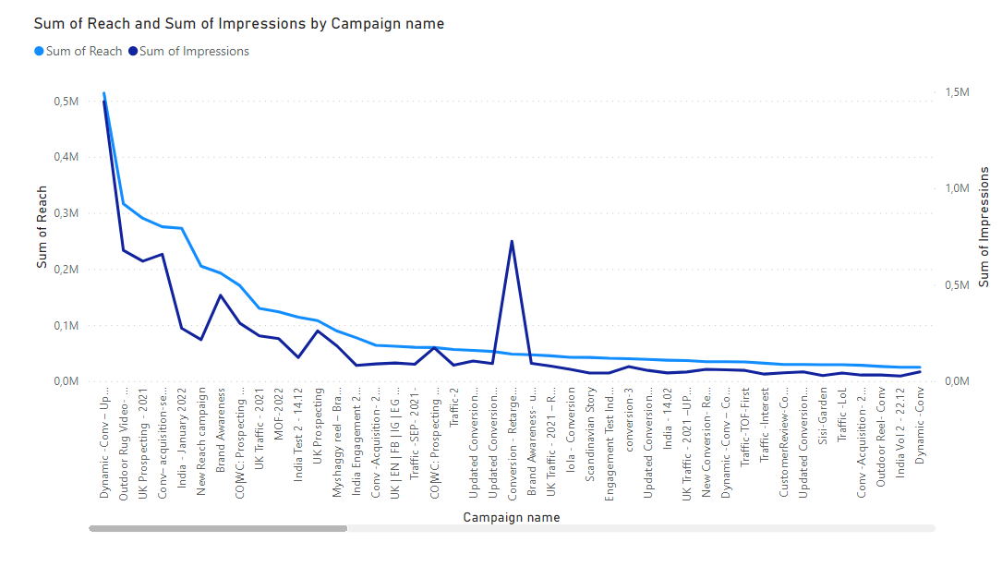

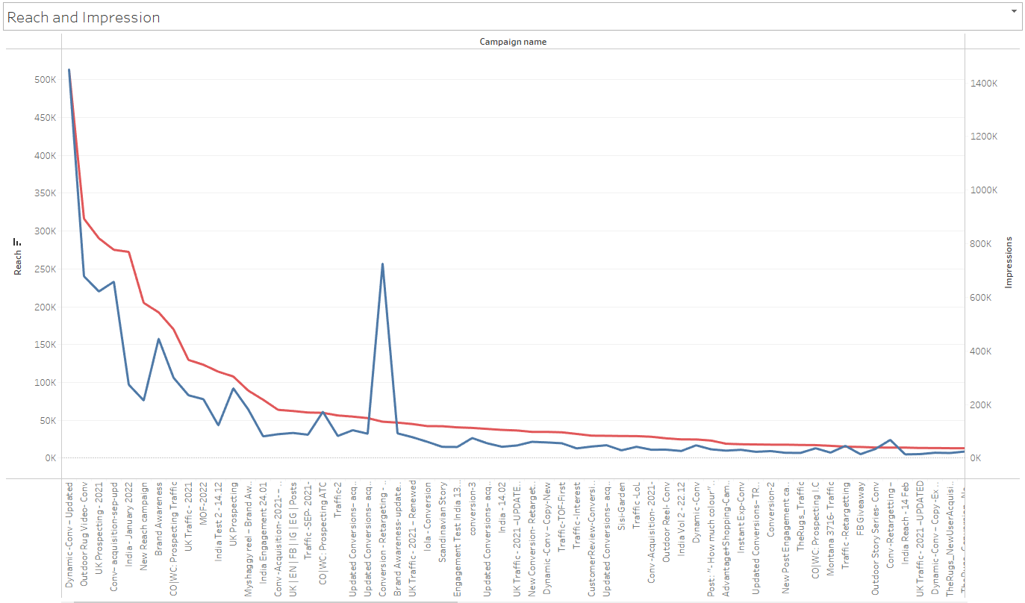

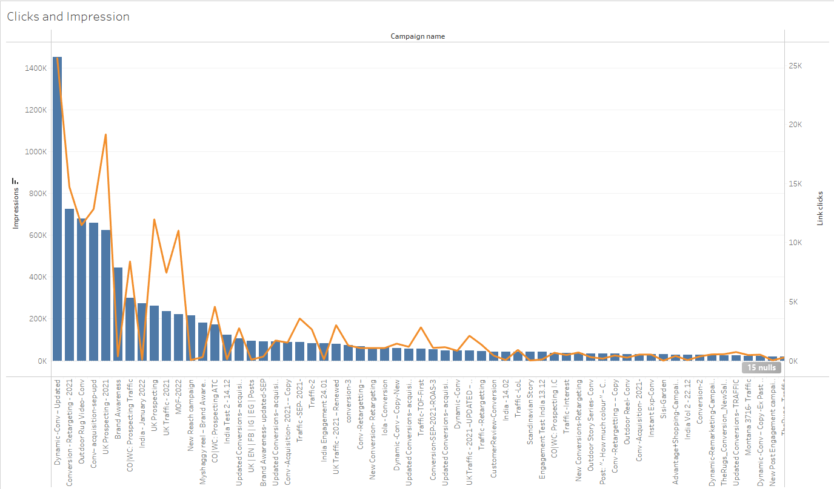

In the image above, you can see the relationship between interaction and the number of people reached. What can be said in this case is that there is a positive relationship between reach and impression.

**5)Checksout and Purchase**

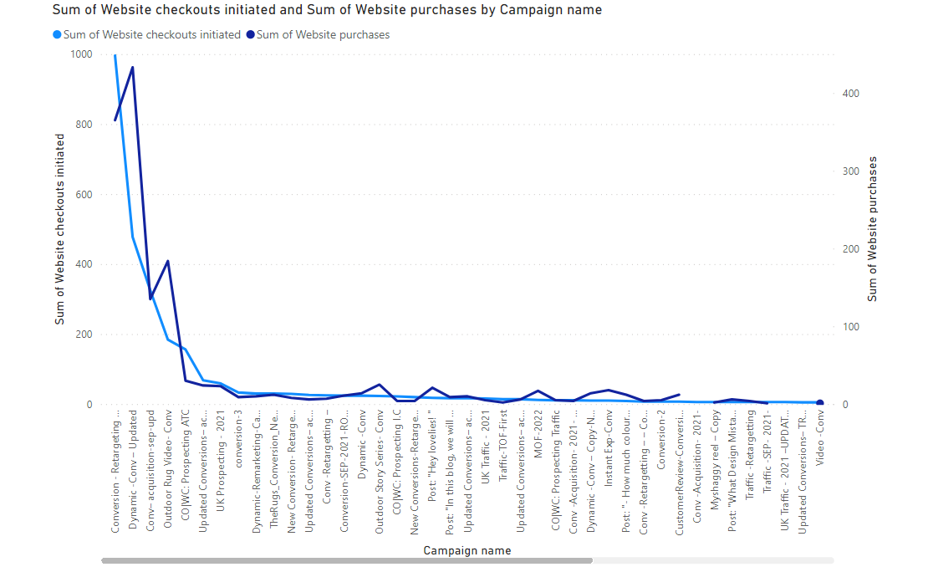

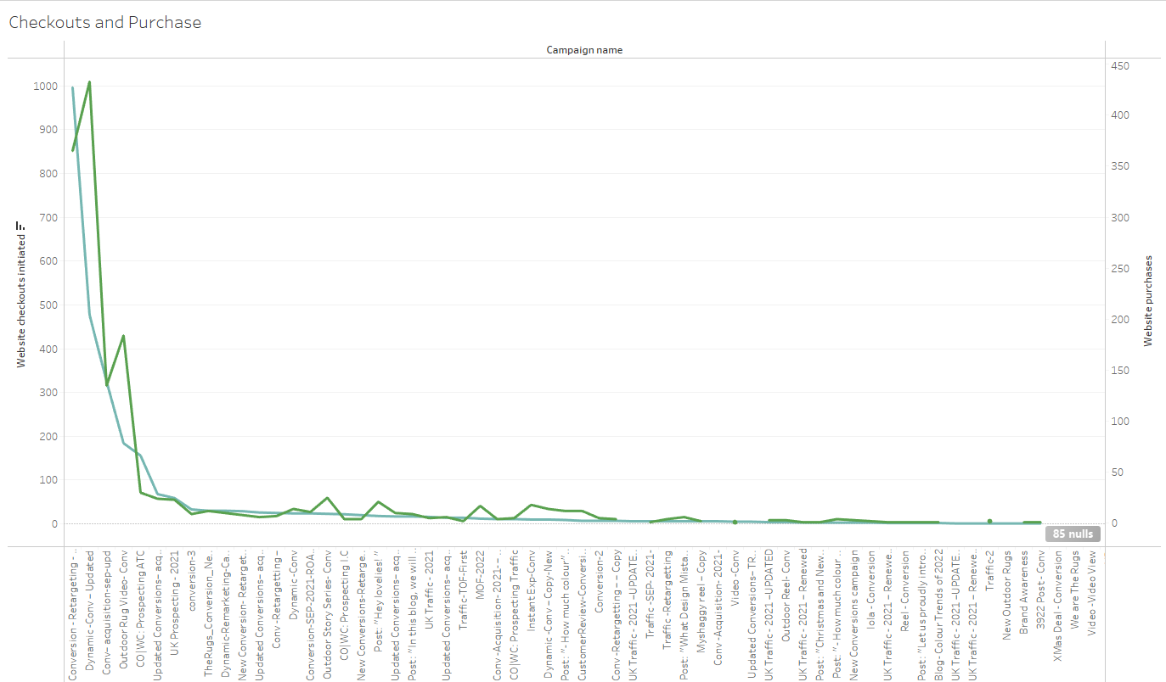

In the graphic above, the relationship between the products placed in the basket and waiting and the products purchased is presented. The result obtained here is that there is a positive relationship between these two.